厦门迪太进出口有限公司
XIAMEN DITAI IMP.& EXP. CO.,LTD
地址：中国厦门禾祥西路鸿升大厦8A
8FL, Hongsheng Building, West Hexiang Road, Xiamen, Fujian, China
TEL:0592-26808108 FAX:0592-2680880 E-mail: irene.zhang@xmditai.com

Sodium Chlorite Food Grade CAS 7758-19-2

The details of Sodium Chlorite Food Grade CAS 7758-19-2

Classification: Chlorate
Type: Sodium Chlorite
CAS No.: 7758-19-2
Other Names: sodium de chlorite
MF: NaCIO2
EINECS No.: 231-836-6
Place of Origin: China
Grade Standard: Food Grade, Industrial Grade
Purity: All kinds of purity
Appearance: White Powder

Packaging and Delivery
Packaging Details
25KG /bag
Delivery Time
30days
Picture as follow:
​
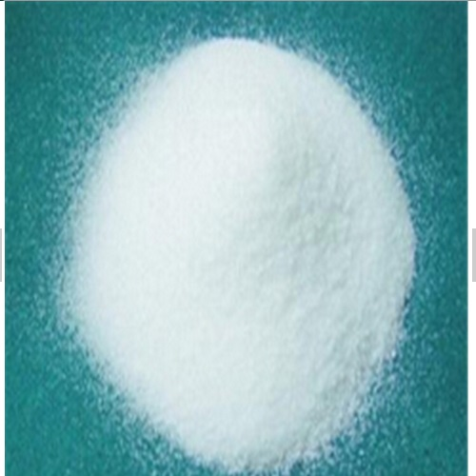

Item | Detail
Purity ,% | ≥99.5
Moisture , % | ≤0.05
Water insolubies,% | ≤0.03
Chloride (based on CI), % | ≤0.02
Bromate (based on SO4 BrO3),% | ≤0.03
Sulfate (based on SO4),% | ≤0.01
Fe (based on Fe ),% | ≤0.003
Residues (125um), % | ≤0.5

